Installation instructions Fitting table

# Run Setup.exe as administrator

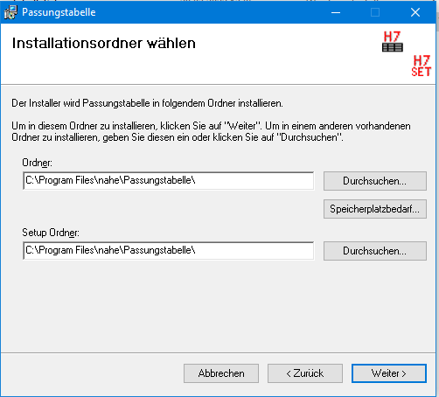

Under "Ordner" enter the installation directory for the add-in  
Preferably this is a local directory and you don´t change the default

# Under "Setup Ornder", specify a directory for the Setup.XML file

# this can be a network directory so that all users use the same settings, for example

# the directory and/or the file can also be write-protected for certain users so that accidental changes to the settings can be prevented

# An existing Setup.XML file is not overwritten during a new installation

# The Setup.XML file can also be saved in the installation directory However, care must then be taken to ensure that this directory has write access

# Typical installation for a multi-user environment

* Add-In is installed locally
* Setup.XML is installed in a network directory and the installation on the individual computers always refers to the same directory for Setup.XML

# Log-File

* The log file is created in the directory "C:\ProgramData\nahe\FitTable"

# Note for network installation of the setup file

* If the network directory/drive cannot be selected in the setup dialog.
  + o Disconnect the network drive
  + o Run cmd.exe as administrator
  + o Reconnect network directory net use LW: \\servername\directory
  + o Then start the setup as administrator